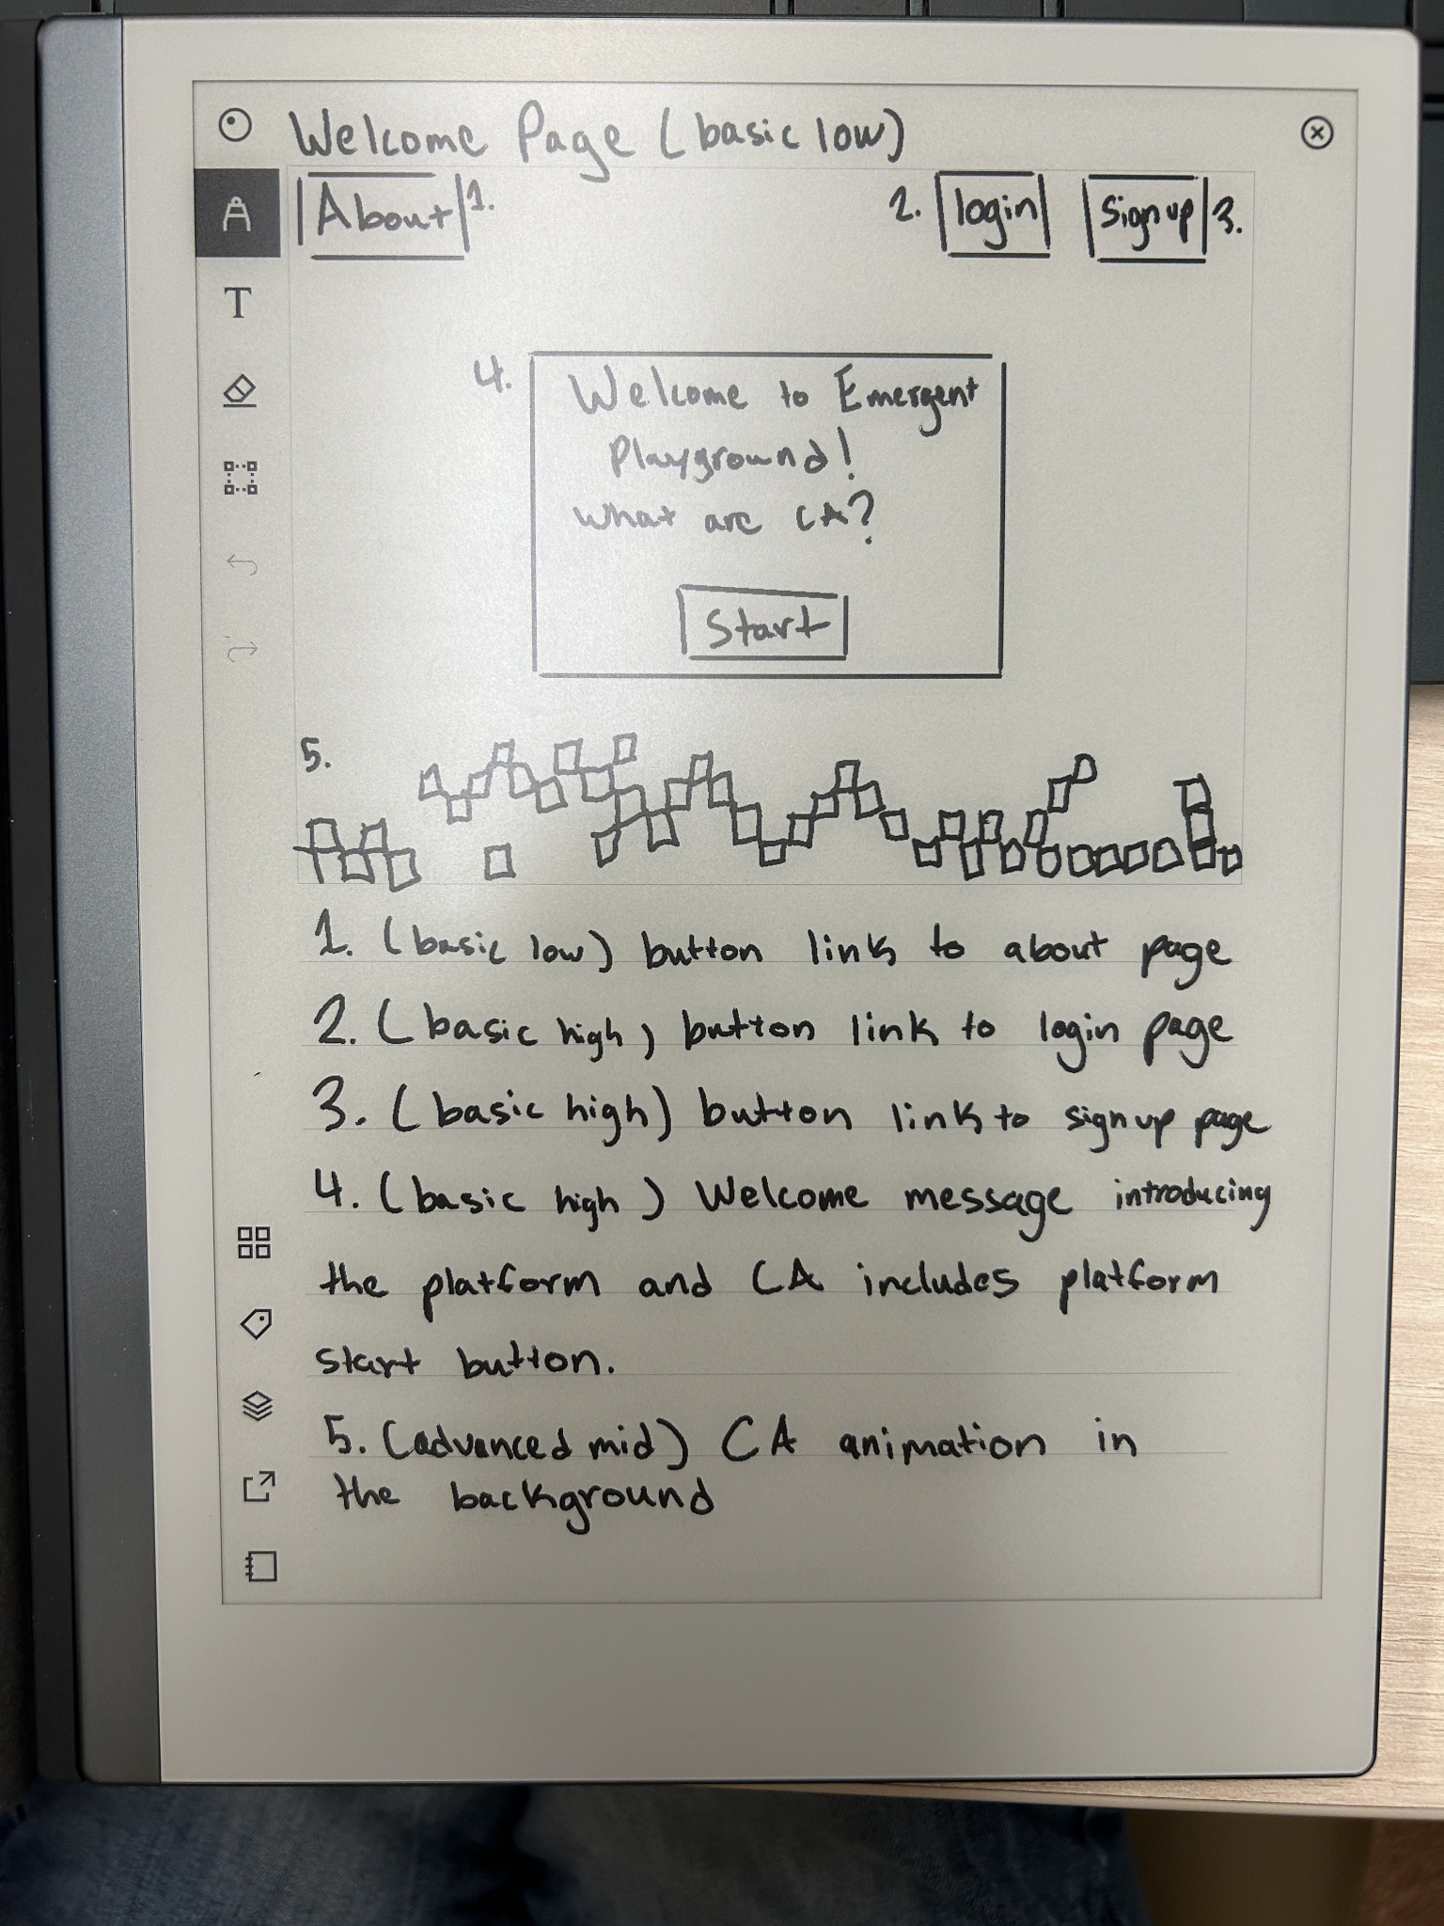

* Gif in background of welcome page
  + Reverse CA gif so that cells come together to from the words WELCOME
* Sentence on what the site is

